How to Debug C# code in Visual studio of azure deployed code in remotely

1. Publish the code/app with debug mode in to azure app service

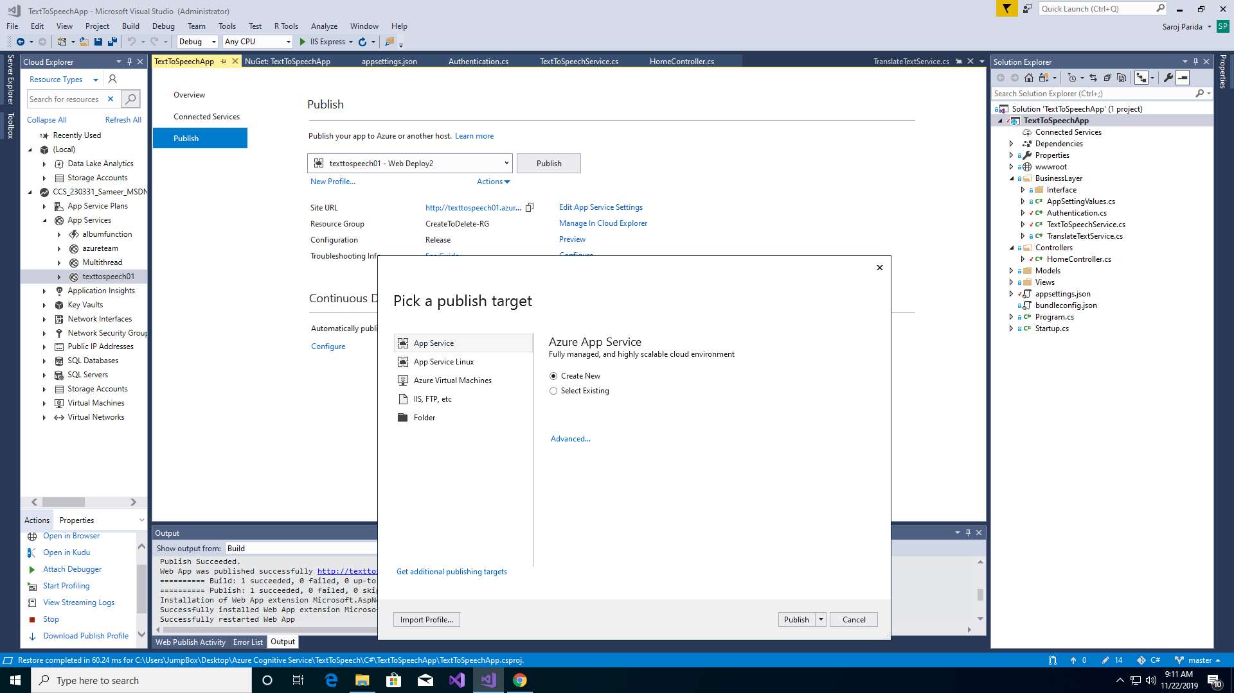

Click on Advance setting-> Select Debug and deploy

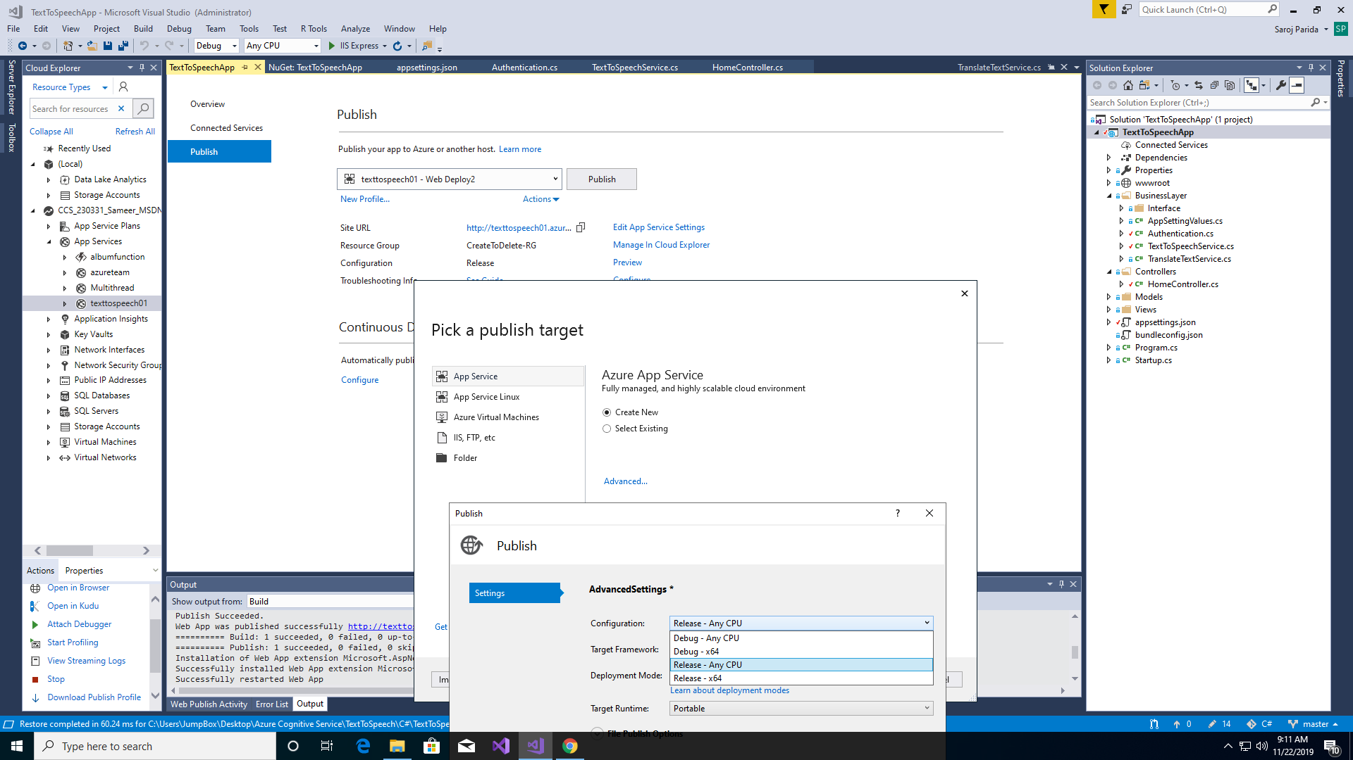

1. Attach debugger

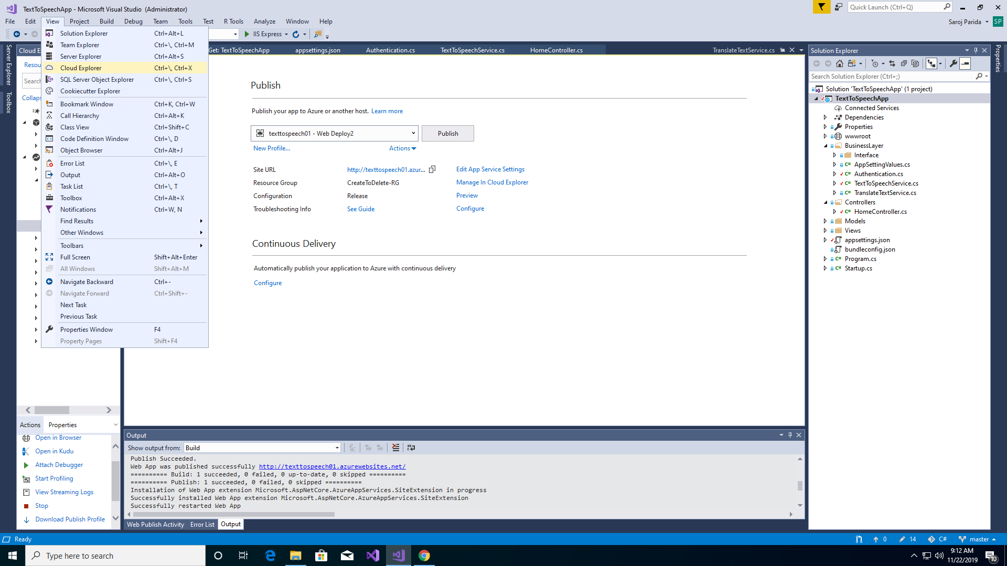

Select the app and click on Attach Debugger option.

